**RUBIO GARCIA RODRIGO.**

**CARLOS ENRIQUE MORAN GARABITO.**

**CINEMATICA DE ROBOTS.**

**PRACTICA 1.**

**8/A MECATRONICA.**

**UPZMG.**

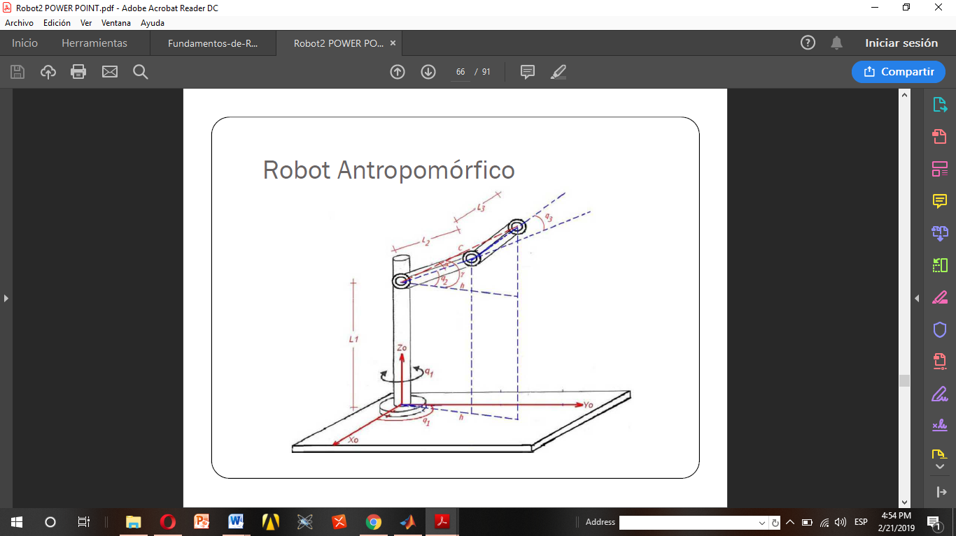

|  |  |  |  |  |
| --- | --- | --- | --- | --- |
| **Eslabón** | **ai-1** | **αi-1** | **di** | **θi** |
| **1** | **0** | **0°** | **0** | **Θ1** |
| **2** | **L2** | **90°** | **0** | **Θ2** |
| **3** | **L3** | **0°** | **0** | **Θ3** |

ca1 = sym('ca1');

sa1 = sym('sa1');

sa2 = sym('sa2');

ca2 = sym('ca2');

l1 = sym('l1');

l2 = sym('l2');

ca3 = sym('ca3');

sa3 = sym('sa3');

A=[ca1,-sa1,0,0;sa1,ca1,0,0;0,0,1,0;0,0,0,1];

B=[ca2,-sa2,0,l1;0,0,-1,0;sa2,ca2,0,0;0,0,0,1];

C=[ca3,-sa3,0,l2;sa3,ca3,0,0;0,0,1,0;0,0,0,1];

r=C*B*A

r =

[ca1*ca2*ca3 - ca3*sa1*sa2, - ca1*ca3*sa2 - ca2*ca3*sa1, sa3, l2 + ca3*l1]

[ca1*ca2*sa3 - sa1*sa2*sa3, - ca1*sa2*sa3 - ca2*sa1*sa3, -ca3, l1*sa3]

[ ca1*sa2 + ca2*sa1, ca1*ca2 - sa1*sa2, 0, 0]

[ 0, 0, 0, 1]

